Industrial Visit 2025-2026
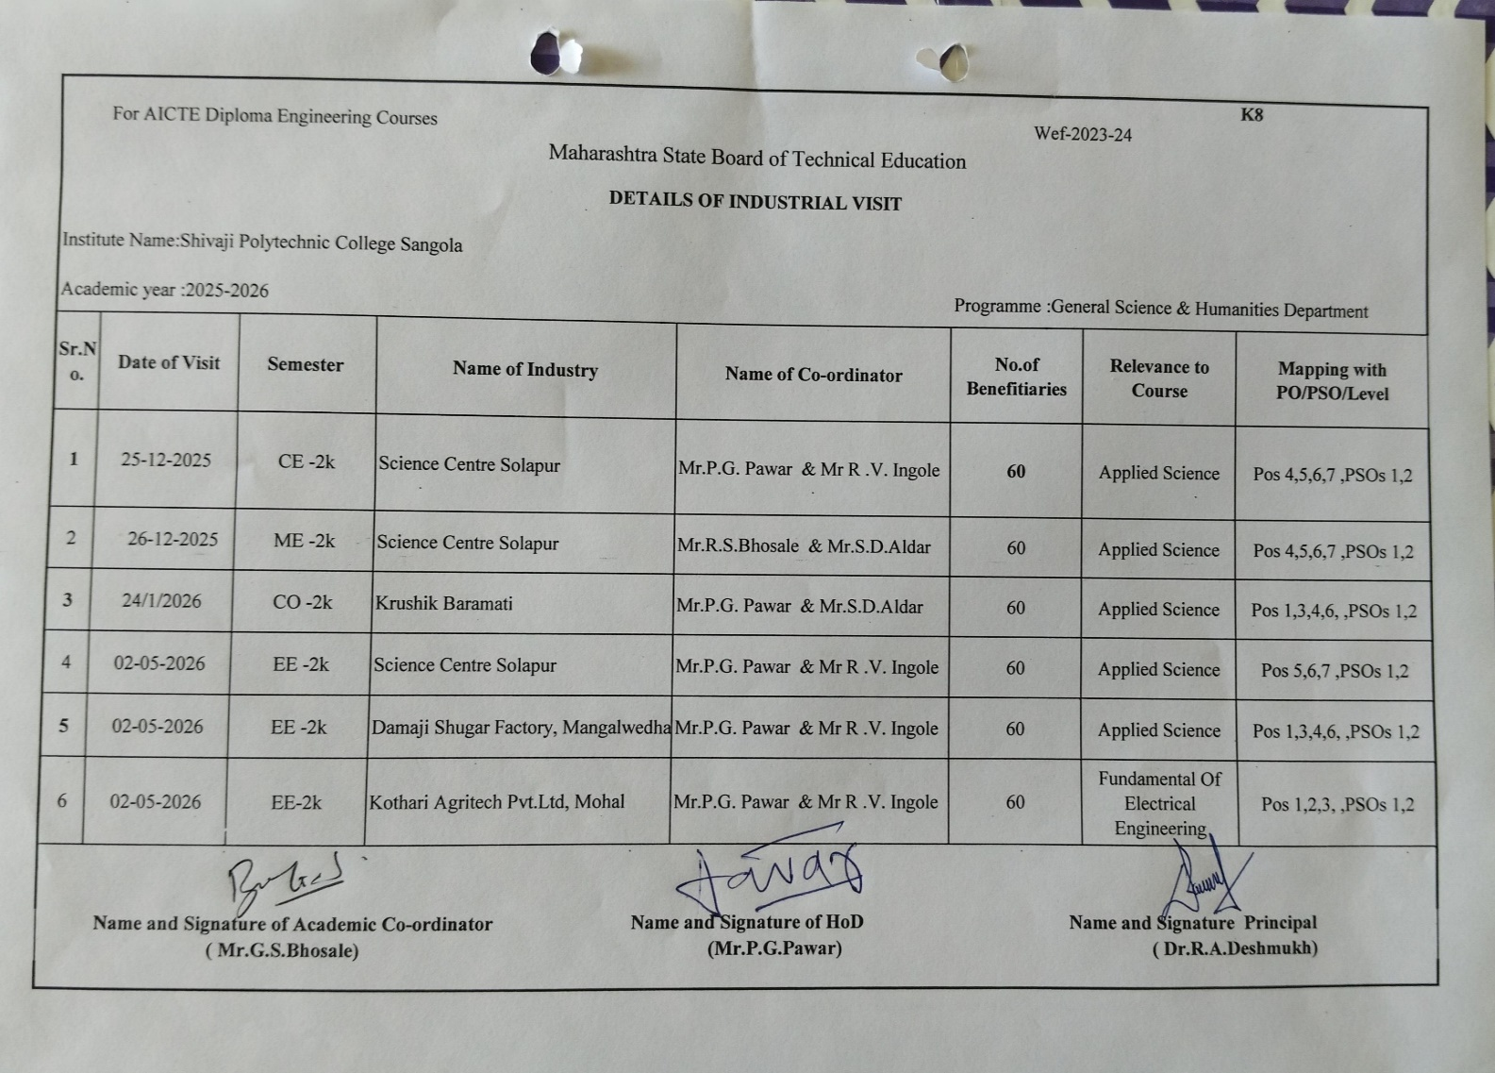

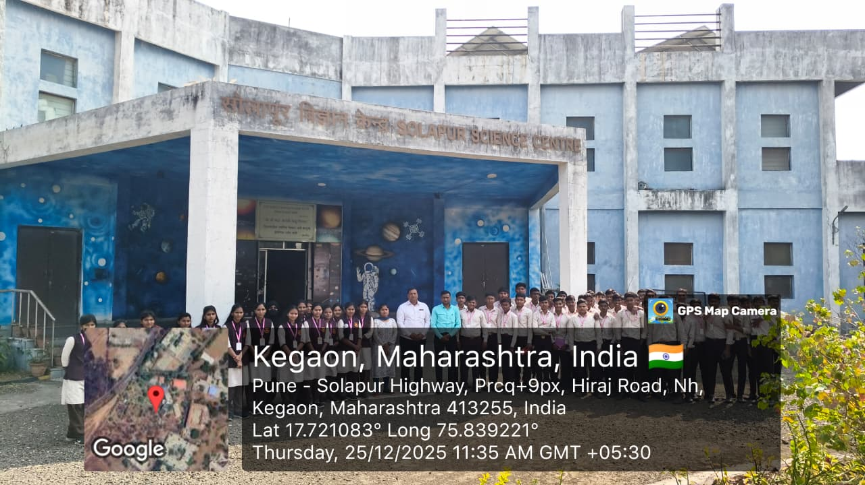

First Year Civil Students Visited Solapur Science Center Solapur
Date- 25-12-2025

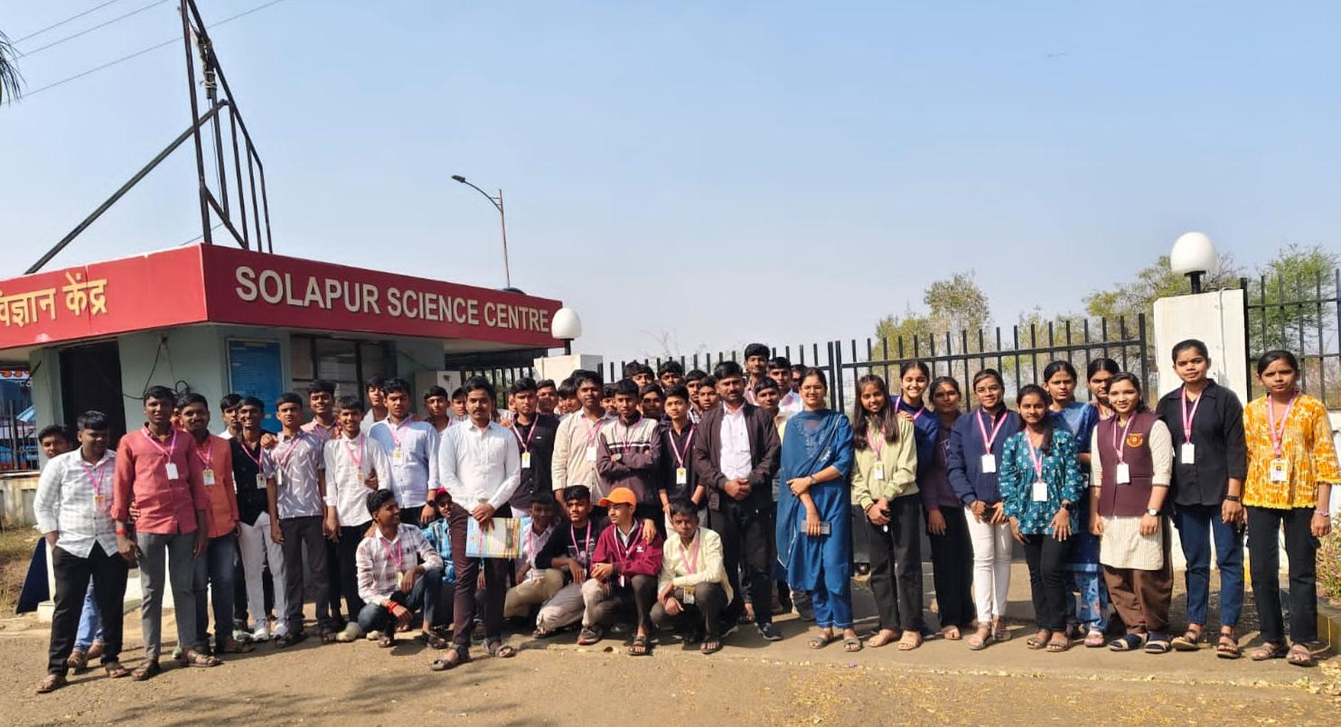
First Year Mechanical Students Visited Solapur Science Center Solapur
Date- 26-12-2025

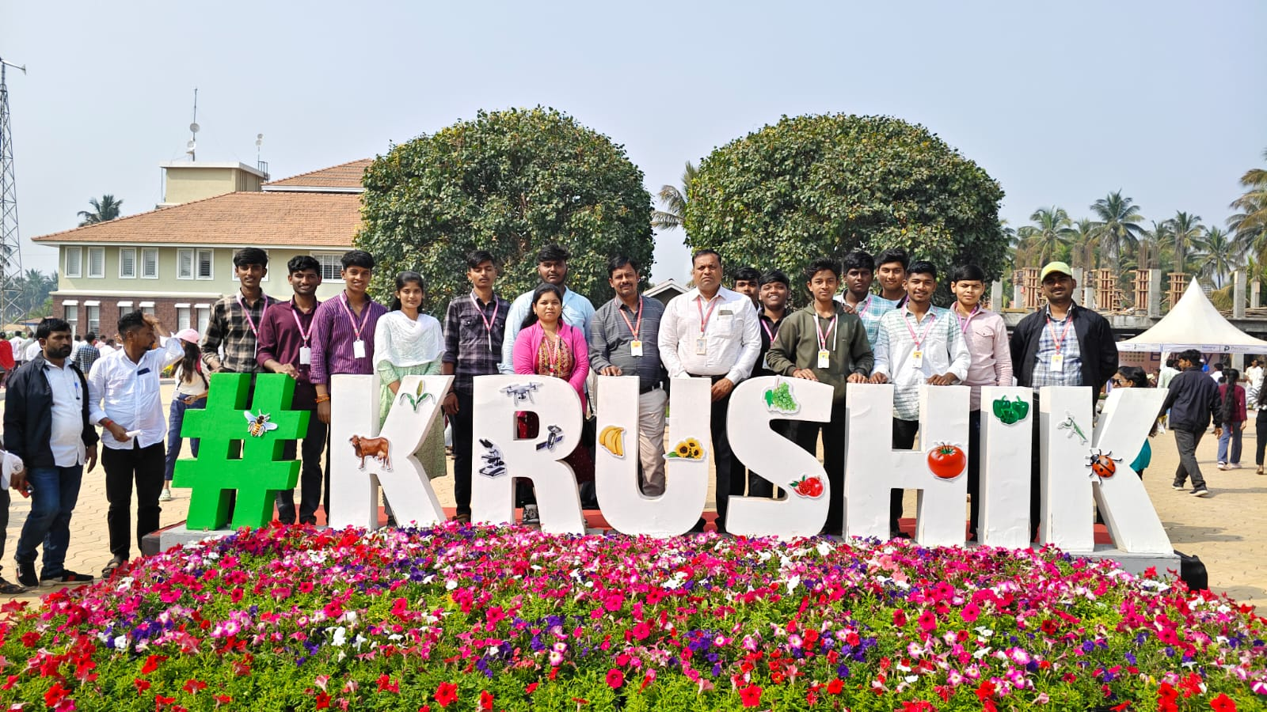

First Year Computer Students Visited #KRUSHIK# Baramati
Date- 24-01-2026

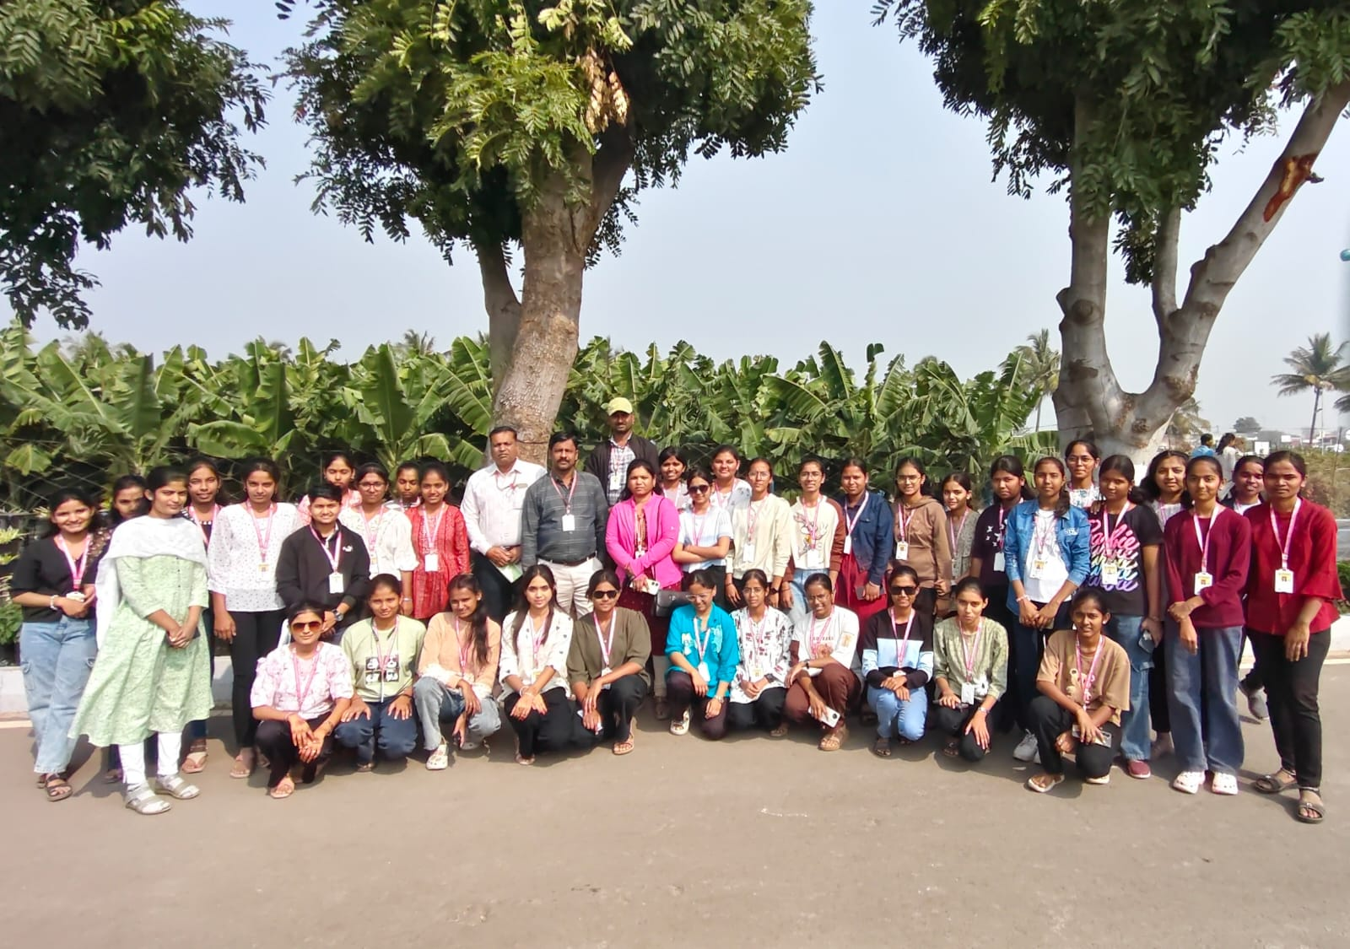

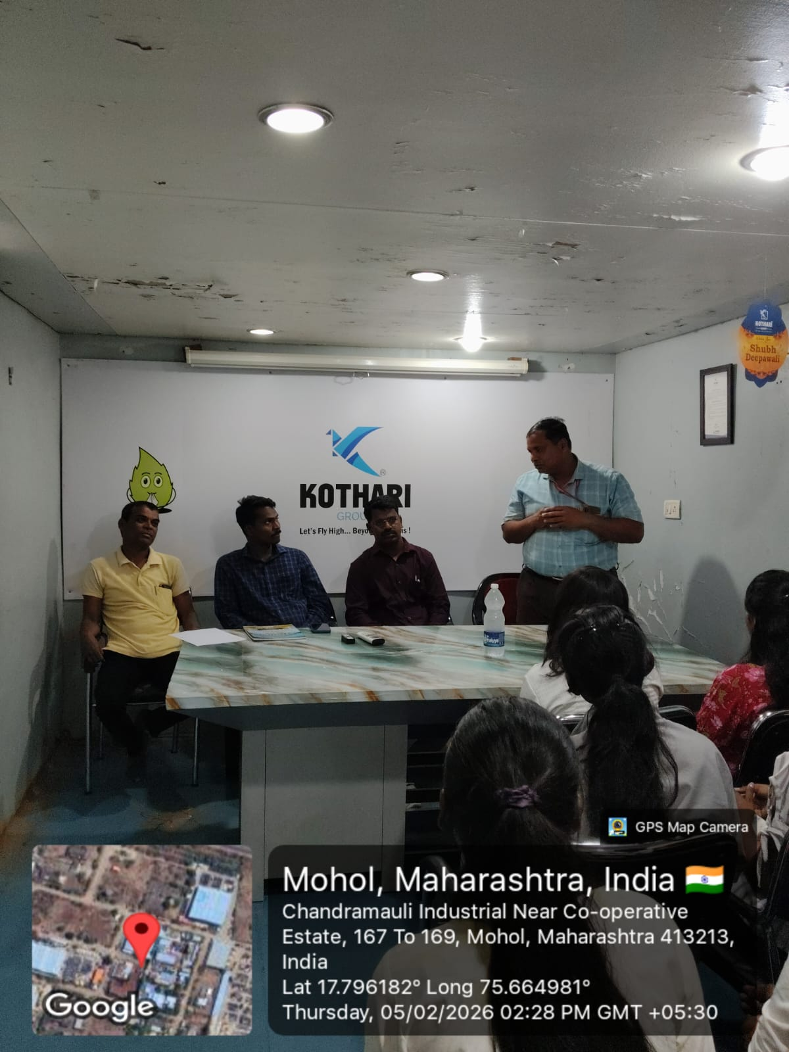
First Year Electrical Students Visited Kothari Agritech Pvt. Ltd
Date- 5-02-2026
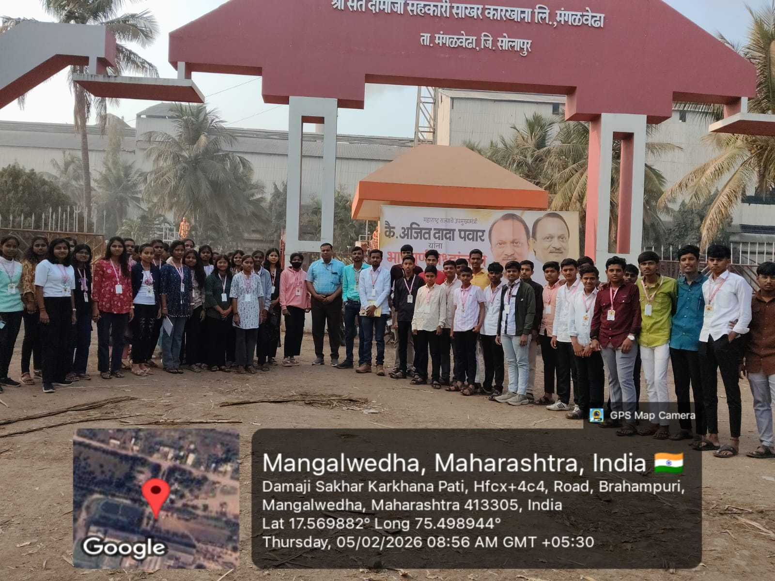
First Year Electrical Students Visited Damaji Sugar Factory , Mangalwedha
Date- 5-02-2026

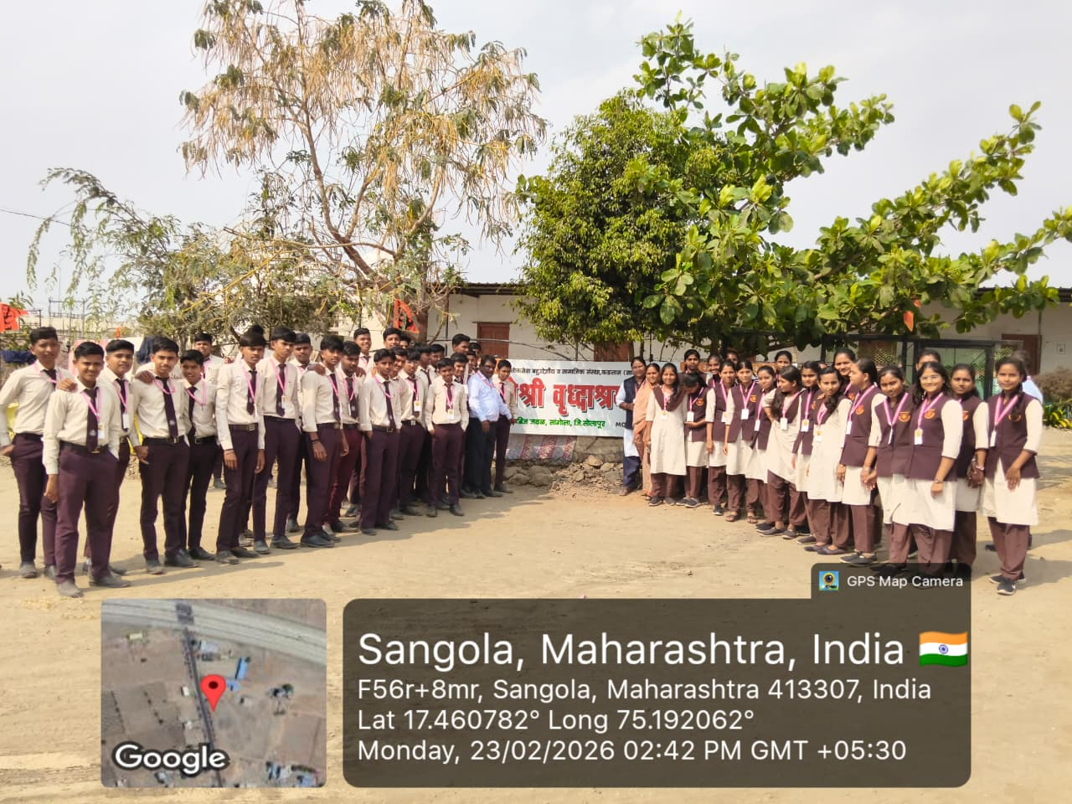
First Year Electrical Students Visited Matoshri Old Age Home
Date- 23-02-2026

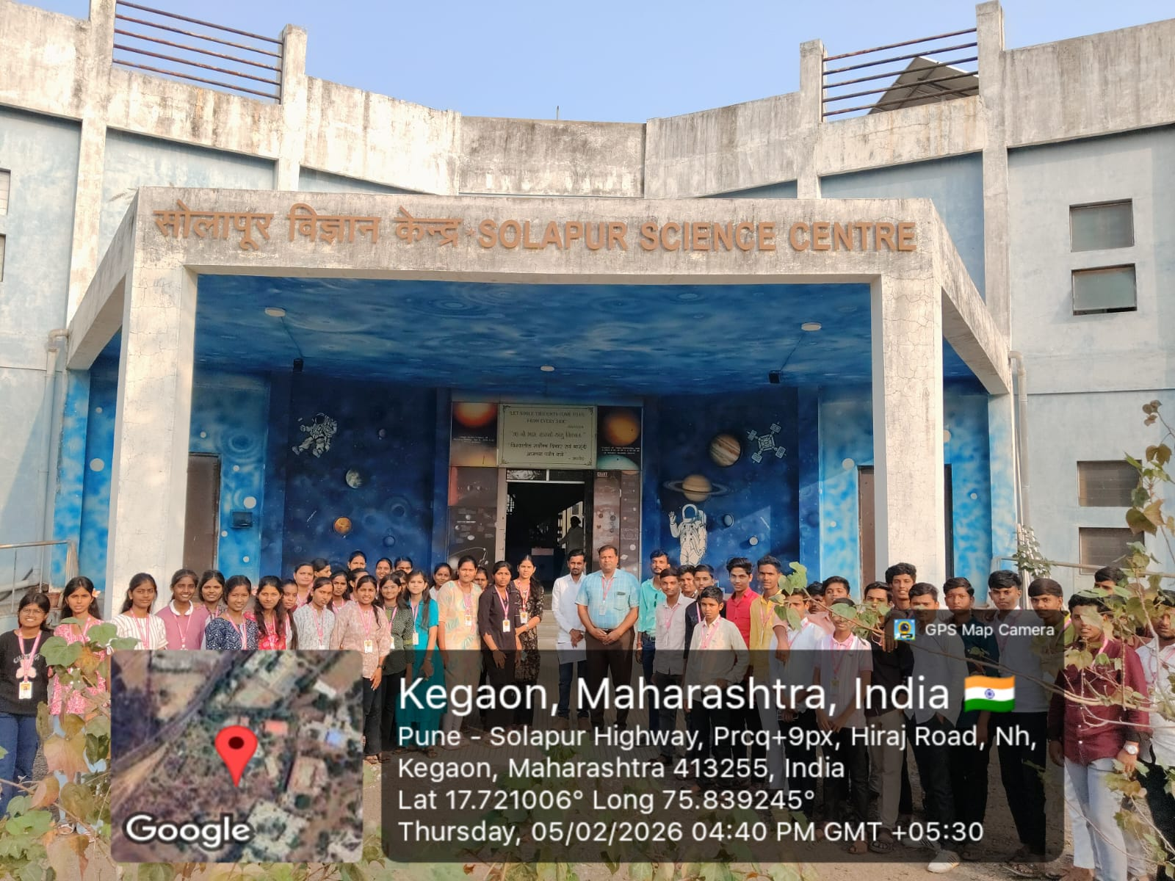

First Year Electrical Students Visited Solapur Science Center Solapur
Date- 5-02-2026

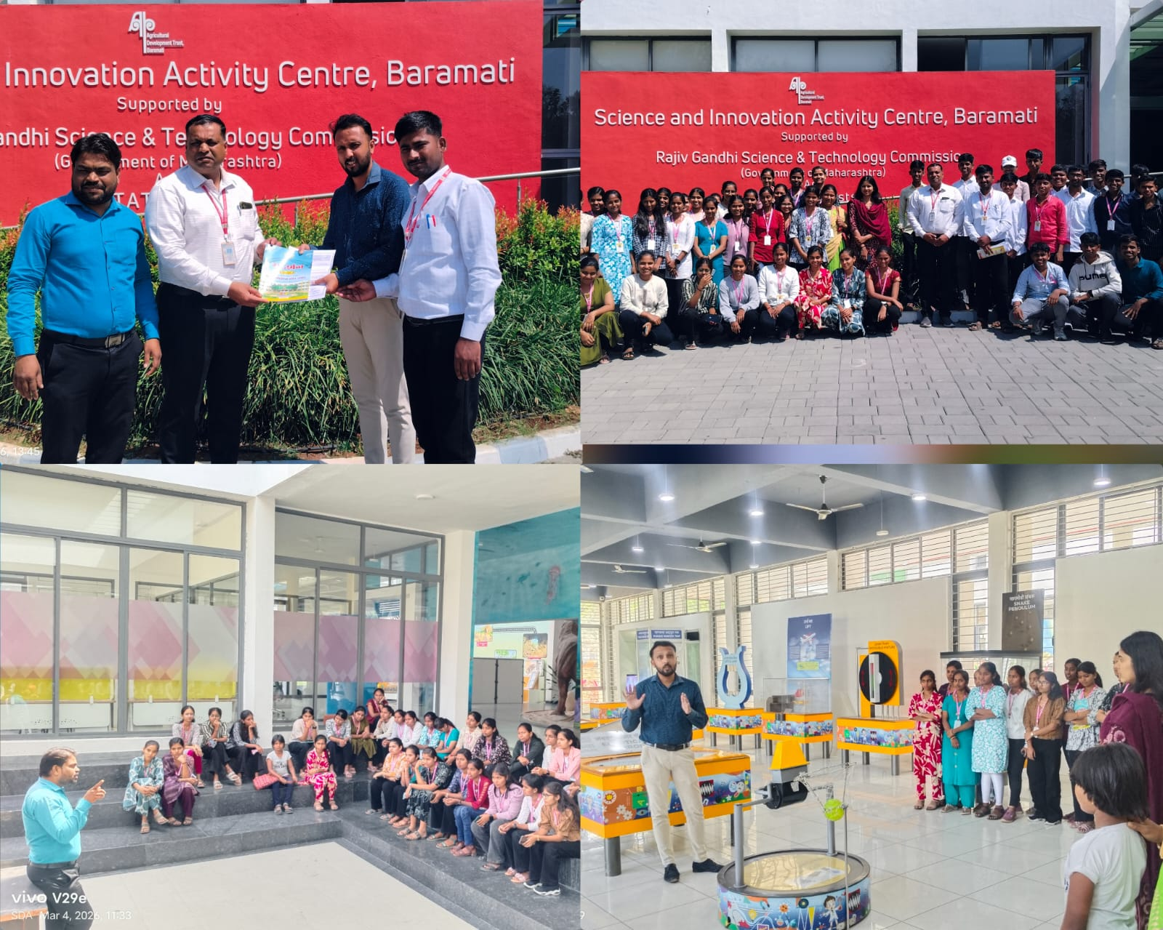

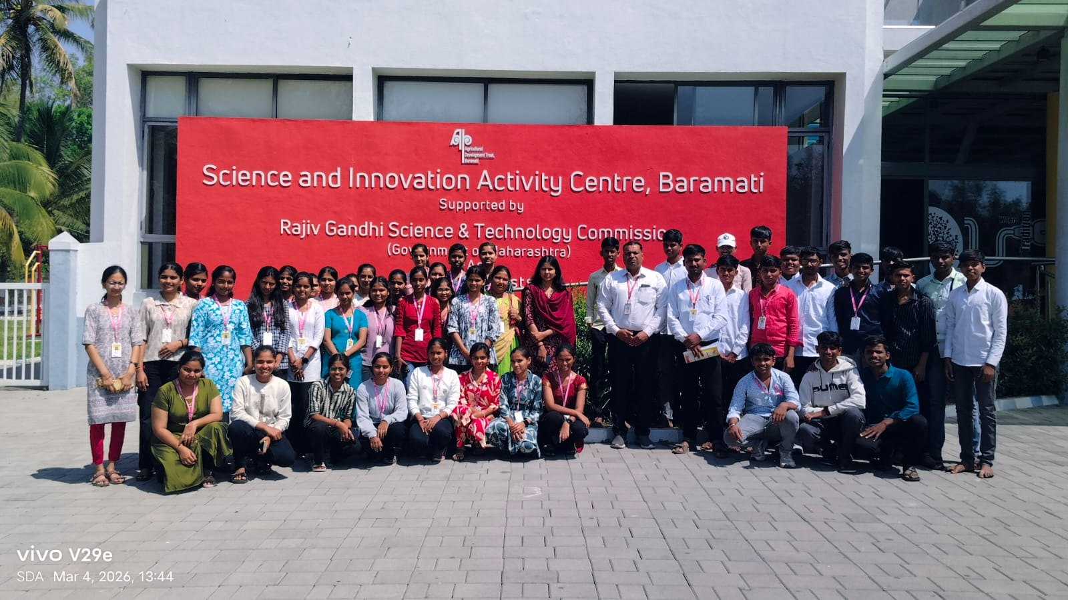

First Year E &TC Visited Solapur Science Center Solapur
Date- 4-03-2026

